## Faculty of Health Sciences

## University of Cape Town

## Merit and Excellence Awards Criteria

## 

**2024**



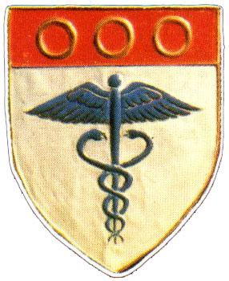

#### 

**Eligibility**

1. Merit Awards

Staff members in categories Lecturer through Associate Professor are eligible for Merit Awards. Merit Awards will be paid as an annual non-pensionable lump sum payment for a period of two years and falls away on promotion to a higher rank.

1. Excellence Awards

These awards are available only to Full Professors. Excellence Awards are monthly payments and are pensionable, and would usually be applied for four years.

Merit and Excellence awards will be based on the faculty ad hominem promotions criteria. Nominations by the HoD or applications by staff members are to be considered via the ad hominem promotions process.

**Faculty-specific criteria**

1. Merit Awards

* Merit awards are part of the academic performance assessment (and thus to be delinked from the ad hominem promotions process)
* Merit awards are to be conferred on a limited number of staff members who have achieved excellent performance in one of the following categories, *Teaching and* *Learning* or *Research* will be considered. These are individuals at the top end of the scale within their rank, with a total score within 2-3 points of the score required for promotion to the next rank.
* Candidates are to be assessed in a competitive process relative to their peers
* Merit awards are competitive in the sense that a limited number, constrained by budget, will be awarded each year (not more than 5% of staff would qualify for these awards in 2024)

1. Excellence Awards

* To qualify for an Excellence 1 Award a candidate would need to score 9/10 in a minimum of two categories, one of which must be Teaching and Learning or Research (recent outputs; 3 to 5 years)
* To qualify for an Excellence 2 Award a candidate would need to score 9/10 in all four categories with an average of score of above 90.
* Candidates will be required to provide corroborative evidence of research outputs, teaching outputs and their leadership and management performance/effectiveness on committees on which they serve.

For more information, please refer to [Merit and Excellence Awards](http://www.hr.uct.ac.za/hr/performance/management/academic_staff/excellence)